Friday, July 31, 2026

Name: Loretto Development Company
Street: 38650 Florence Drive
City / State: Willoughby Hills, Ohio
Zip Code: 44094

BLUEBERRY HILL SUBDIVISION

DESCRIPTION OF SERVICE(s)...

- CEI Staking
 Filing in our office

Total Amount Due: $885.00

Please make CHECK OR MONEY ORDER Payable to: DELMAR B. KOSIE & ASSOC.
If after 30 days payment is not received a late fee of 1.5% of the total amount due will be added per/month until total payment is received.

Due to the different sizes of envelopes used, and current mailing procedures, Your Plat of Survey (survey map) will probably arrive later than this invoice. If after 5(five) working days you have still not received the Plat of Survey, please contact us.

Thank-You for your business.

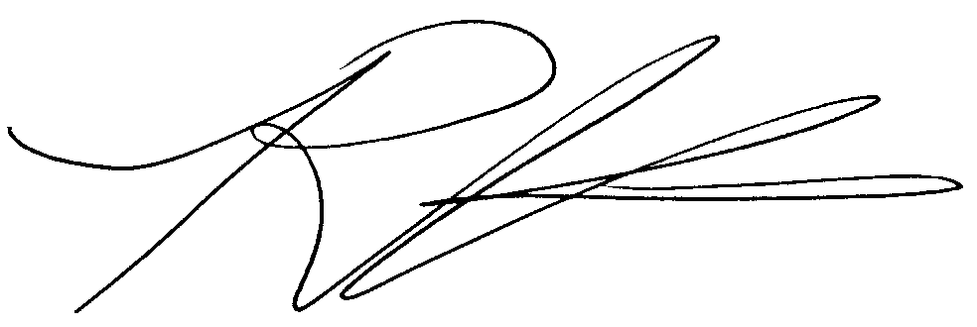
Robert L. Kosie
Crew Chief

